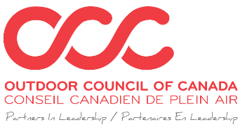

COVID-19 PRINCIPLES AND EMERGING PRACTICES FOR SCHOOL AGE LED OUTDOOR ACTIVITIES IN BRITISH COLOMBIA AND YUKON

* This document is an appendix to the COVID-19 Principles and Emerging Practices of the Canadian Led Outdoor Activity Sector

Working References
- BC AdventureSmart
- Outdoor Council of Canada-Response to COVID-19
- BC Adventure Programs
- BC Camps Associations
- School Age Child Care Association
- Yukon Summer Day Camp Guidelines

About Us
The school age sector’s Led Outdoor Activities operate on proven real-world strategies and safety protocols, which ensure the health, learning and safety of staff and participants. School age refers to children aged 6 to 17 years participating in daylong outdoor experiential education based activities supervised by program staff and/or certified teachers. Led Outdoor Activities are taught and supervised within an outdoor setting where participants learn social, life and outdoor skills supporting their social emotional learning and childhood development.

Our sector strives to provide year-round inclusive, adaptive, and responsive school age LOA for all British Columbian and Yukon children. Led Outdoor Activities range from hiking, paddle sports, recreation, swimming, biking, forest foraging, wilderness survival and others. Outside spaces and settings may include utilization of urban parks, forests, wilderness trails, beaches and waterways.

As a sector, LOA already recognizes and manages a host of transmissible infections from a variety of vectors including environmental, fecal-oral, topical, and respiratory. A large body of academic literature and field expertise recognizes that risk and uncertainty are central features of the physical, psychological, and social benefits of LOA. As such, we accept reasonable levels of consent-based risk in our work and have developed operating standards and best practices for managing the transmission of infection.

The decisions needed, changing concerns, and evolving awareness of COVID-19 is a multi-layered and complex challenge for which we are well prepared. School aged LOA are ready, capable and designed to lead young participants into the wilderness with reasonable levels of risk to health and safety.

Distinguishing Benchmarks for School Age Led Outdoor Activities
- Risk management policies and operating procedures, constant review process and continuous staff training
- Programming and delivery adjustments are designed in consultation with numerous resources, and with the understanding that service providers aim to reduce risk as much as possible, with no guarantees the health of all its staff and participants
- Appropriate level First Aid training for program staff
- Staff trained in a variety of ways including specialized professional certification, organizational staff training, mentorship, and communities of practice
- Affiliated membership providing guidance and/or compliance (e.g., RCABC, Paddle Canada, AdventureSmart, SACCA, OCC, Life Saving Society)
- RCMP Criminal Record Clearance for working with vulnerable populations
- Ongoing safety management processes including documenting and reviewing safety on a regular basis
- Adherence to several industry and public safety guidelines (e.g., Ministry of Education and Ministry of Transportation’s Marine Safety protocols)

School age led outdoor activity management is characterized by the following;
- Participant age (grades one to twelve)
- Day long and local (7:30am – 6:00pm range)
- Small group focused (i.e. 4 to 12 participants with two instructors leading with children and youth)
- Outdoor experiential education and skills focused
- Mobile, contained, and organizationally supported groups
- Readiness and risk management designed

Preparation and Prevention of COVID-19
School Aged service providers have identified and used BC’s five principles and Yukon’s “Safe Six Steps” in the control plan for every situation pertaining to staff and participants in the development of specific group management plans, including:

BC’s Five Principles: Yukon’s “Safe Six Steps”:
-Personal Hygiene -Safe Physical Distancing
-Stay at Home if you are Sick -Wash your Hands Frequently
-Environmental Hygiene -Stay Home if you are Feeling Sick
-Safe Physical Distancing -Don’t gather in groups of 10 or more
-Physical Modification -Limit travel to rural communities
-Self isolate

The contexts in which these principles are employed follow BC’s “Hierarchy of Controls” model. Note that while the controls are listed in order of effectiveness, all four types of controls have been considered and they often work best in combination.

The hierarchies of controls for COVID-19 which are fundamental to the information the outdoor recreation sector needs to support safer operations are:

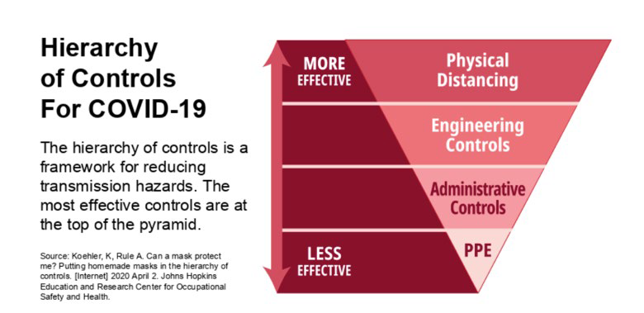

https://www2.gov.bc.ca/assets/gov/public-safety-and-emergency-services/emergency-preparedness-response-recovery/gdx/bcs_restart_plan_web.pdf
https://www.energeticcity.ca/wp-content/uploads/2020/05/BC-Restart-Plan.pdf

Yukon’s “Safe Six Steps” have been reinforced in A path forward, Yukon’s reopening plan
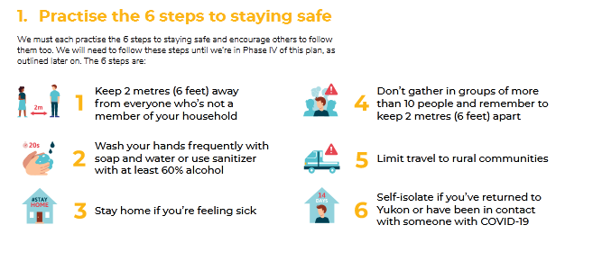
School Age LOA providers following sources as guidance
- Government of Canada: Risk informed decision making guidelines
- BC Centre for Disease Control: Risk-informed decision-making COVID-19 guidelines for work places
- WorkSafeBC provides an exposure control plan guide
- Government of Yukon – Yukon Summer Day Camp Guidelines
- Yukon's WCH&SB provides resources for returning to the workplace

LOA Protocols
- Physical distancing within the group will be observed as much as possible
- Physical distancing will be incorporated into the games and activities as much as possible
- LOA will distance from members of the public as much as possible
- LOA will be adjusted so that physical contact between participants is limited as much as possible
- LOA with close physical contact will be limited
- Depending on the size of the LOA program, lunchtimes may be staggered to allow for smaller groups within the undercover spaces
- All shared LOA equipment and supplies will be cleaned down when appropriate, (at the end of each day, or between each user) with soap and water or wiped down with public health approved sanitizer
- Sharing supplies and equipment will be minimized as much as possible
- Any tables and chairs used throughout the day will be sanitized at the end of each day
- Items that are impossible to clean will be avoided, or participants will be given personalized take-home supplies (i.e.: crayons)
- All participants MUST bring their own supply of water for the day in their own water bottle. Emergency water will be on hand if needed. No sharing of food will be permitted

Workplace Safety Practices Employer Responsibilities and Protocols
- Establish, train, and monitor all practices related to safety and hygiene
- Ensure practices are carried out as scheduled
- Review your organizations 2020 policy and procedures, insurance coverage, legal documentation, and membership accreditation if applicable
- Adjust and adapt best practices as required
- Provide proper protective and sanitation supplies
- Provide a safe and healthy workplace

Communication
Ensure employees are kept informed, and fully understand, expectations around hygiene, company policies, safe work practices, and protocols will ensure better compliance. When travelling in remote locations to have means of communication (e.g., satellite phone).

Employee Specialized Training
- Training and education will be provided to all employees, contractors, service providers, visitors, or other parties that enter the premises
- Training includes safety measures and procedures, physical distancing, proper hygiene practices, and monitoring and reporting illness
- Emphasis should also be given to employee training regarding trauma informed practices when working with children, youth, and vulnerable populations
- Focus is employee readiness and preparedness

Employee Responsibilities
- Do not come to work if you are feeling ill
- If employee is feeling ill with signs of COVID stay home and self-isolate for a minimum of 10 days from the onset of symptoms, or until symptoms have completely cleared
- Do not come to work if a member of your household has tested positive for COVID-19, is awaiting a COVID-19 test result, or has a probable case of COVID-19.
- A return to work date will be determined in consultation with public health officials
- Do not come to work if you have traveled internationally within 14 days prior to their first day of work
- Maintain a high level of personal hygiene at all times following provincial/territorial guidelines
- Follow the health and safety guidelines provided by the employer and provincial/territorial Health Officer for staff, client and facility health and hygiene procedures
- Instruct all participants on health and safety procedures for LOA
- Monitor participants for signs of illness and, if noticed, isolate them from the rest of the participants group. Inform their manager if there is an incident of illness
- Stay consistent with one group of participants from week to week
- Do not switch out days with other staff members
- When splitting into groups, each staff member will stay consistent with their group of participants for that week

Pre-Trip Planning
- A prescreening questionnaire to ensure the participant is healthy before travelling and eligible to participate
- A waiver and informed consent to be signed by the participant before any money is paid to the operator (guardian if underage of 18) as part of the liability insurance
- An orientation message at the first point of contact reconfirming their health and welcoming them to participate
- Overview and expectation of participants adherence to the Best Management Practices
- Prepare an Outdoor Participants Medical Management Plan for those with more complex needs that is co-created by the family, and if needed a medical professional (i.e. compromised auto-immunity, epilepsy, diabetes)
- Prepare an Outdoor Medical Management Plan for Containment and Evacuation
- Training for participants will take place in a two-step process, including a prescreening questionnaire and an on-site orientation

*For BC: Temperature checks upon arrival are done as per the BC Public Health Minister’s recommendations. As per the BC Public Health Minister’s recommendations, participants will not be required to wear masks. Participants and staff may do so if they choose.

*For Yukon: Day camps must screen all staff and campers for COVID-19-like symptoms. All staff and all campers should be asked at arrival each day if they have any of the following symptoms:
- cough;
- fever;
- shortness of breath; or
- a general feeling of being unwell.
Staff and campers with any of the above symptoms cannot attend camp

Orientation
- At the first point of in-person contact with participants, all participants must again self-declare their health status, and be given a COVID-19 orientation by the LOA operator
- The orientation will include an explanation of the safety measures and procedures, physical distancing, proper hygiene practices, and monitoring and reporting illness
- These safety measures require the cooperation of all clients through adherence to our policies and procedures
- A full list of the COVID-19 measures implemented is provided on documents that are available on government websites and on business premise

Participant Requirements
- Participants must declare any illness to staff
- Participants must maintain a high level of personal hygiene, including frequent hand washing or the use of a sanitizer. In addition, respiratory etiquette is essential in preventing the spread of illness. The key elements of respiratory etiquette are:
  - Covering cough/sneeze into a sleeve or tissue
  - Disposing of used tissues in garbage
  - Cleaning hands after coughing or sneezing

Cleaning, Sanitizing Protocols and Disinfectants that meet Health Canada's requirements
- Hard surfaces will be often cleaned and disinfected using approved products
- Textiles, neoprene, and other products requiring specialized detergents and sanitation will be cleaned after each use according to manufacturer’s direction and dried preferably in open air and sunshine
- Disinfectants that meet Health Canada's requirements for COVID-19

Transportation
- Transportation services will follow Transport Canada guidelines for surface, marine and air transport
- All participants and staff must comply with the Public Health Agency of Canada face covering/mask directives for cloth or disposable facemasks when required. The vehicle will be disinfected after every use
- All participants will wash or sanitize their hands immediately after exiting the vehicle

Exposure Control Plans and Mitigation Strategies
Identify and Assess
- Identify symptoms suspect of COVID-19 by observing and conversing with participant
- Immediate participant physical distancing measures from group (minimum 15-25 feet)
- Assess participant(s) and record symptoms (date, time, and actual symptoms) in expedition/out-trip logbook
- Review COVID-19 symptom chart (mild-severe), participant intake notes and individual health report
- Contact, inform and consult with your organization’s designated field supervisor and local medical authority for potential COVID-19 guidance
- Isolate participant from the rest of the group
- Consider additional disinfect and wash group equipment as precaution

Mitigate, Isolate and Monitor
- Follow directives from health authority (see: Yukon Summer Day Camp Guidelines)
- Participants wear individual PPE if applicable (cloth mask and gloves)
- Revise management and expedition travel plan if required
- Continue participant isolation from the rest of the group
- Monitor participant and group symptoms
- If participant’s symptoms are worsening, call field supervisor and local health authority
- If other members display similar symptoms, call field supervisor and local health authority
- Enact group containment strategic plan for duration of expedition

Continue or Exit
- Seek guidance from health authority to continue expedition or exit participant and/or group (see: Yukon Summer Day Camp Guidelines)
- Absolutely no contact with anyone outside your group
- PPE mandatory when exiting for group members
- Seek permission for immediate testing of participants and instructors
- Mandatory 14-day participant quarantine post-expedition if participant has confirmed infection

Post-Expedition
- Submit incident report to field supervisor
- Follow up with participant(s) to ensure quarantining is taking place
- Follow up with health authority and await direction

Supporting Organizations

Outdoor Council of Canada
National organization promoting outdoor education and activity
https://www.outdoorcouncil.ca/

Wilderness Tourism Association of the Yukon
Yukon non-profit association advocating on behalf of Yukon’s wilderness tourism sector
https://wtay.com/

Yukon Government - Department of Health and Social Services
Yukon Summer Day Camp Guidelines: COVID-19

BC AdventureSmart is supported 100% by the BC SAR Association and operates on a different model than the rest of Canada.)

BC AdventureSmart Reports listed below (via BC SAR Association's website, on our platform page)
- Summer 2018 Final Report
- Winter 2018-19 Final Report
- Summer 2019 Final Report
- Winter 2019-20 Final Report
BC AdventureSmart Twitter
BC AdventureSmart Facebook
BC AdventureSmart Instagram

